Artes Mundi 11, Presenting Partner: Bagri Foundation
ANTONIO PAUCAR WINS ELEVENTH ANNIVERSARY ARTES MUNDI PRIZE
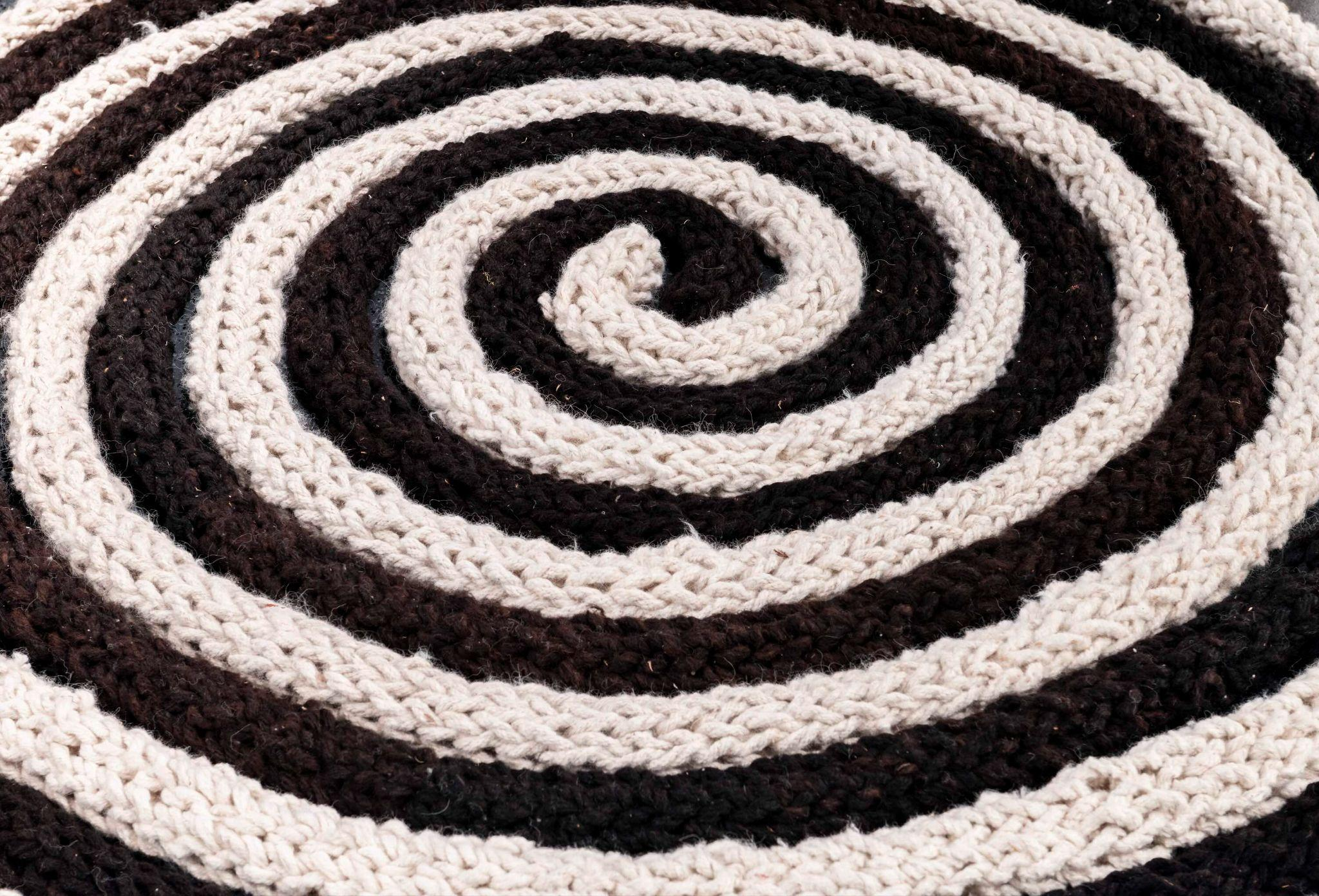
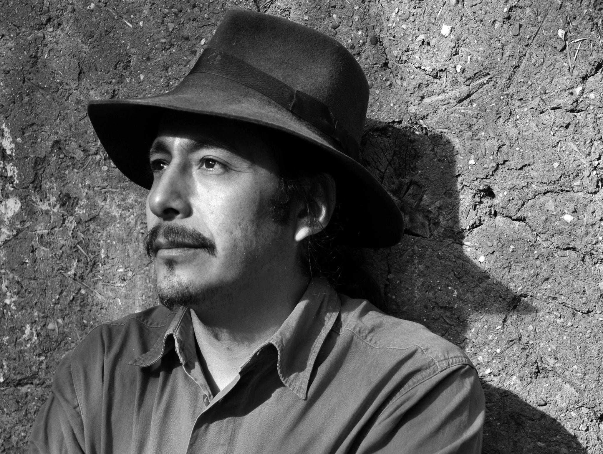
With presenting partner the Bagri Foundation, Artes Mundi, the UK’s leading biennial exhibition and international contemporary art prize, has announced Antonio Paucar (born 1973 Huancayo, Peru; lives and works in Berlin and Huancayo) as the winner of the Artes Mundi 11 (AM11) prize, with an award sum of £40,000. Alongside him, Sancintya Mohini Simpson (born 1991 Meeanjin/Brisbane, lives and works in Meeanjin/Brisbane, Australia) has been named as the Derek Williams Trust Artes Mundi Purchase Prize winner, resulting in one or more of her works acquired from the exhibitions for Amgueddfa Cymru - Museum Wales. Paucar and Simpson are two of six international contemporary visual artists whose work is currently on show across five venue partners in Wales until 1 March 2025 for the eleventh anniversary edition of Artes Mundi. Paucar’s work is presented at Mostyn in Llandudno, with Mohini Simpson’s work at Chapter in Cardiff, alongside the group show at National Museum Cardiff.

Antonio Paucar creates a unique artistic language through performances, sculpture and related video. Drawing on his origins and the material culture of his indigenous Andean background, his practice poetically tackles contemporary conflicts faced by indigenous peoples and the ensuing environmental threats to place and home. For AM11, Paucar presents a series of new and existing large-scale hand woven alpaca wool sculptures and related performance videos of their making that result from live performances reflective of rituals and interventions. At Mostyn, Paucar’s presentation comprises the large-scale textile sculpture Illapa (2021) and a projection of the performance video Suspendio en la Quenua (2014). Alongside these works, Paucar revisits an earlier work to create a new performance rooted in the material location of North Wales. The imprint of the action of performing a handstand against the gallery wall, with feet covered in clay, is shown alongside a film of the performance. At National Museum Cardiff, Paucar presents the newly expanded performance La Energia Espiral del AYNI II comprising the video performance and resulting object of a spiralling black and white alpaca wool circle. El Corazón de la Montaña (2018-19) sees the artist in the Huaytapallana mountain range, an area under threat through significant glacier retreat, loss of water resources, ecological damage and increased hazards for the communities dependent on its ecosystem and water supplies. It is a place of worship and spirituality for the Mantaro Andean people. Using his own blood, Paucar writes a sentence in his native language, wanka lima (Quechua wanka), which means: "The heart of the sacred mountains is weeping blood."

In a shared statement, the Artes Mundi 11 Jury said: “For over twenty years, Artes Mundi has been a leading platform in contemporary art, contributing to the shaping of the field by introducing new and under-recognised voices and positions; supporting different modes of presentation, and methods of making and sharing work whilst ensuring that these positions and methodologies reach the widest audiences in Wales and internationally. In AM 11, what we found particularly compelling, beyond the strength of the artistic positions, was how the organisation distributed the exhibitions across the country to highlight the work of art communities outside the centre, ensuring that resources and works could be shared with audiences nationwide.”

“We find all presentations deserving of recognition, as all artists are confronting the pressing matters of our times from a situated position and with unwavering rigour. After extensive deliberation, we nominate Antonio Paucar for AM11 Prize, as an artist whose expansive practice encapsulates a long-term commitment to and engagement with his local environment and communities, creating work that speaks powerfully to marginalised contexts and extracted histories. His sensitive economy of means, grounded in nature, sustainability and attention to resource scarcity, embraces a material and visual experimentation of incisive poetic gestures that extends their reach beyond the limits of constraining political imaginaries. Paucar’s practice, alongside all other presentations, aligns with Artes Mundi’s support of practices that exist outside the pressures and prototypes of the art market while remaining committed to artistic freedom and experimentation.”

Sancintya Mohini Simpson is a descendant of indentured labourers sent from India to work on colonial sugar plantations in South Africa. Rooted in this familial background, her work navigates the complexities of migration, memory and trauma, addressing gaps and silences within the colonial archive. Her practice spans painting, video, poetry, and performance, reflecting on her maternal lineage through narratives and rituals. A large-scale multi-panelled watercolour and gouache work on paper referencing Indian miniature painting traditions as well as the aerial view landscapes common in Indigenous Australian art, is presented at National Museum Cardiff, on loan from MCA, Sydney, Australia. Alongside it is Sugar Vessels, a work in which three black clay vessels (fired in sugar cane mulch) become symbols for body, water and boat, referencing migratory ocean voyages and the dark history and residue of the sugar industry.

The Derek Williams Trust Purchase Prize enables a work of art by an Artes Mundi shortlisted artist to be acquired by Amgueddfa Cymru - Museum Wales for its permanent collection of contemporary art. Previous recipients of the award have included Prabhakar Pachpute, Ragnar Kjartansson, Bedwyr Williams, Tanya Bruguera and Anna Boghiguian.

Jamie Seaton, selector for The Derek Williams Trust said: “The Derek Williams Trust is absolutely delighted that Sancintya Mohini Simpson has been awarded the Derek Williams Trust Artes Mundi Purchase Prize. The judging panel was impressed by the breadth of the artist’s work which, spanning painting, sculpture, installation, film, performance and the written word, holds to a clear individuality and unity of purpose. The works on paper particularly impressed: the employment of North Indian miniature techniques traditionally associated with mythologised histories serving to universalise the injustices depicted, while the works’ delicacy, accuracy and beauty brings the viewer paradoxically - and shockingly - right back, face to face, with specific horrors.”

As a vital platform of cultural exchange between the UK and global artistic communities centred on the ongoing examination of the ‘human condition’, Artes Mundi brings together a significant biennial exhibition of contemporary art from impactful international artists. AM11 continues its legacy of presenting exceptional work in Wales that engages with the significant issues of our time. The solo presentation locations for AM11 are: Anawana Haloba and Sawangwongse Yawnghwe at Aberystwyth Arts Centre, Aberystwyth; Sancintya Mohini Simpson at Chapter, Cardiff; Kameelah Janan Rasheed at Glynn Vivian Art Gallery, Swansea; and Jumana Emil Abboud and Antonio Paucar at Mostyn, Llandudno. All artists are represented in a group presentation at National Museum Cardiff, acting as a central focal hub including ambitious new productions and major museum loans, that speak to the fundamental core of each artist’s practice. The group show allows thematic dialogue to be revealed between each artist, rooted in personal histories and storytelling that examines issues of loss, memory, and migration with consequent trauma and environmental cost. This is augmented by in-depth solo exhibitions across the country.

-ENDS-

ALL PRESS ENQUIRIES
Matthew Brown at Sam Talbot | matthew@sam-talbot.com | +44 (0) 7989 446557
Flora Guildford at Sam Talbot | flora@sam-talbot.com | +44 (0) 7708 786516

WELSH LANGUAGE PRESS
Mary Dunbar at Artes Mundi | mary.dunbar@artesmundi.org

IMAGE CAPTIONS (L-R)
Antonio Paucar, Installation view at National Museum Cardiff, Artes Mundi 11, 2025-26. Photography by Robin Maggs.
Antonio Paucar portrait, photography by Jorge Jaime Valdez.

NOTES TO EDITORS

ABOUT THE WINNER OF THE ARTES MUNDI 11 PRIZE

Antonio Paucar (b. 1973) draws from his origins in Andean culture through rituals and interventions, his art tackles contemporary conflicts, the assassination of indigenous leaders, environmental threats, and surveillance technology. Paucar's work establishes dialogues with Andean and indigenous knowledge, often in critical tension with Western culture, offering a multifaceted perspective. He has been exhibited worldwide, and his works are part of major international collections including at MoMA in New York the Institut für Auslandsbeziehungen in Berlin, the Museum of Contemporary Art in Sao Paulo, the Montreal Museum of Fine Arts, the Museo de Arte de Lima, and the Wrocław Contemporary Museum in Poland. He lives and works between Berlin, Germany, and Huancayo, Peru.

ABOUT THE WINNER OF THE DEREK WILLIAMS TRUST PURCHASE PRIZE

Sancintya Mohini Simpson (b. 1991) is a descendant of indentured labourers sent from India to work on colonial sugar plantations in South Africa. Her work navigates the complexities of migration, memory, and trauma— addressing gaps and silences within the colonial archive. Her work spans painting, video, poetry, and performance, reflecting on her maternal lineage through narratives and rituals. Simpson has had recent solo exhibitions at Milani Gallery, Institute of Modern Art Belltower, Brisbane and 1ShanthiRoad Studio Gallery, Bangalore. Group exhibitions include the 2023 TarraWarra Biennial and the 2022 Busan Biennale. Simpson's poetry is published in various journals, and her work is held in major collections, including the Art Gallery of New South Wales, Art Jameel, Dubai; KADIST, Paris and the Museum of Contemporary Art Australia, Sydney; she is represented by Milani Gallery, Meeanjin/Brisbane.

ABOUT ARTES MUNDI 11
Key Information
Exhibition Runs: 24 October 2025 - 1 March 2026
Admission: Free
Information: www.artesmundi.org | info@artesmundi.org | @artesmundi

EXHIBITION VENUES
Aberystwyth Arts Centre, Aberystwyth University, Penglais Campus, Aberystwyth SY23 3DE
Chapter, Market Road, Canton, Cardiff, CF5 1QE
Glynn Vivian Art Gallery, Alexandra Road, Swansea, SA1 5DZ
MOSTYN, 12 Vaughan Street, Llandudno, LL30 1AB
National Museum Cardiff, Cathays Park, Cardiff, CF10 3NP

ABOUT ARTES MUNDI
Artes Mundi is the key flagship international visual arts organisation for Wales based in Cardiff, UK and a member of the Plus Tate network. Established in 2002, Artes Mundi is committed to working with artists whose work engages with social reality and lived experience. The Artes Mundi exhibition and prize takes place biennially, while alongside these is a sustained public programme, co-creative community partnerships, projects and commissions. Previous winners are Taloi Havini (2024), Apichatpong Weerasethakul (2019), John Akomfrah (2017), Theaster Gates (2015), Teresa Margolles (2013), Yael Bartana (2010), N S Harsha (2008), Eija-Liisa Ahtila (2006), and Xu Bing (2004). In an Artes Mundi first, the jury unanimously decided to award the Artes Mundi 9 Prize to all six shortlisted artists in 2021.

The Bagri Foundation was the Presenting Partner for Artes Mundi 10 (2023) and is Presenting Partner for Artes Mundi 11 (2025).
Artes Mundi receives core funding from the Arts Council of Wales alongside other support including Welsh Government, British Council, various Foundations, Trusts, embassies, cultural agencies and individuals.

ABOUT THE BAGRI FOUNDATION

The Bagri Foundation, established in 1990, is a family foundation driven by a spirit of curiosity. Our vision is to cultivate a meaningful space for Asian culture to thrive, shift perspectives and deepen connections.

The Foundation works within a network of leading cultural organisations who share this mission, to give artists and experts from across Asia, wider visibility on the global stage. We champion diverse artistic initiatives that challenge and inspire us and our audiences. Through grants and strategic partnerships, we realise unique, high-quality programmes which share traditional and contemporary Asian culture.

Recent projects include support for the major exhibition Asian Bronze: 4000 years of Beauty at the Rijksmuseum, Amsterdam; Myths, Dreams and New Realities featuring 13 emerging Asian artists co-curated with the Saatchi Gallery; a co-production, Thikra: Night of Remembering, by Akram Khan Company; and the first retrospective outside of India of Arpita Singh’s work at the Serpentine Gallery, London.

In addition to the arts programme, three generations of the family continue to support education, relief work, development and healthcare.

https://bagrifoundation.org

ABOUT THE DEREK WILLIAMS TRUST
The Derek Williams Trust was founded in 1992 to support learning and appreciation of visual culture through public display of works of art. Since 1993, the Trust has worked in close partnership with Amgueddfa Cymru – Museum Wales, collecting art in all its forms from post-1900 to the present day. The Trust acquires art for both its own collection, which is held on long term loan at Amgueddfa Cymru and also supports Amgueddfa Cymru in purchases of modern and contemporary art, together building a collection of international significance.

ABOUT THE VENUES
Aberystwyth Arts Centre (Aberystwyth) is one of the largest Arts Centre’s in Wales and is a multi-art-form venue producing and presenting a programme of theatre, film, music, exhibitions alongside a creative learning programme that serves the university campus, Ceredigion community and beyond. Our exhibitions programme gives a platform to showcase the very best in contemporary art, exhibiting work by national and international contemporary artists. We offer a high-quality environment to display work, with one of the largest contemporary art spaces in Wales in our purpose-built Gallery 1 for established artists and large-scale exhibitions, Gallery 2 as a dedicated space to support our next generation of emerging artists and the café gallery and Piazza window space for community focused work. We have a rolling programme of artist in residencies with our specially built studio space, giving artists opportunities to develop their own practice in a supportive environment. www.aberystwythartscentre.co.uk

Chapter is an international centre for contemporary arts and culture, rooted in the heart of Cardiff, Wales. Established by artists in 1971 to celebrate experimentation and radical thought, it’s been a catalyst for creativity and critical thinking ever since.
They commission and present thought-provoking exhibitions, films, performances and multidisciplinary events by established and emerging contemporary artists who expand our worldview and challenge the status quo. Embracing multiple and diverse perspectives, risk-taking and experimentation, their programme encourages conversations that cross boundaries and disciplines.
The artists they work with actively engage with the critical questions and issues that shape our present and they foster dialogue between audiences and artists via a public programme that provides opportunities to connect through our histories, the way we live now and how we might imagine new futures.
Alongside their expansive public programme, they work behind the scenes to support the creative community in their 50+ studios and beyond, bringing people together to encourage ideas and collective agency. https://www.chapter.org
Swansea Council’s Glynn Vivian Art Gallery plays a vital role in local society and as part of the creative ecosystem across Wales. Through exhibitions, collaborative projects, social engagement, learning, outreach and education we work with local audiences and communities. Our programmes focus on excellence, equality, health and wellbeing, supporting artists and the most vulnerable in our society. We support local artists through exhibitions, awards, acquisitions and employment, as well as bringing some of the world’s leading artists to Wales. We present major exhibitions and new commissions, working in partnership with many local, national and international organisations. Our collection of artworks and ceramics belongs to the people of Swansea and forms an important part of the city’s cultural memory. Glynn Vivian Art Gallery is an Arts Council of Wales Arts Portfolio organisation and a part of Plus Tate and Visual Arts Group Wales. www.glynnvivian.co.uk

Mostyn is a free, public gallery in Llandudno, Wales, that presents a programme of outstanding international contemporary art within its galleries and online. This programme has recently included solo exhibitions by Jeremy Deller, Cerith Wyn-Evans, Jacqueline de Jong, Paul Maheke, Vanessa da Silva, Revital Cohen and Tuur Van Balen, Rosemarie Castoro and Noemie Goudal. Mostyn offers a public engagement programme including talks, tours and workshops, and supports over 400 artists through their onsite and online shop. Mostyn receives support from the Arts Council of Wales and is part of Plus TATE, the UK-wide contemporary visual art network. www.mostyn.org
Amgueddfa Cymru - Museum Wales belongs to everyone and is here for everyone to use. We’re a charity and a family of seven national museums, located across the country. Our aim is to inspire everyone through Wales’ story, at our museums, in communities and digitally. Our welcome is free thanks to funding from the Welsh Government and extends to people from all communities. Covering six centuries and displayed over 24 galleries at National Museum Cardiff, Amgueddfa Cymru’s art collection features some of the most recognisable names: Claude Monet, Paul Cézanne, Vincent Van Gogh, Gwen John, Barbara Hepworth and Henry Moore. Amgueddfa Cymru’s partnership with Artes Mundi has brought international scope to its contemporary collections that continues the tradition of the Davies sisters' bequest of Impressionist and post-Impressionist works in the 20th century. Through this collaboration, supported by the Derek Williams Trust, acquisitions have been made from artists including Bedwyr Williams, Tania Bruguera, Mounira Al Solh, Prabhakar Pachpute and Berni Searle, amongst many others. Follow Amgueddfa Cymru’s seven museums on Instagram and Facebook. Play your part in Wales’ story: by visiting, volunteering, joining, donating. www.museum.wales

